INVENTORY MANAGEMENT SYSTEMSWeek 2 Assignment 1:Inventory Management

Strayer University

How to manage an Inventory Systems

**INVENTORY MANAGEMENT SYSTEMS**

**Introduction**

Last year , I went to see my Mother whom I had not seen for fifteen year in Africa. It was one of my most memorable momet in my life. I had to flight for fourteen hour which was one of my longest flight I had ever had. I was kind of scared because we were on the ocean for twelve hours. I was very happy to be there which made my famiy to have a big dinner. During a dinner, my sister Veronica who has a small clothing store express her frustration about having to manually track and reorder items which were on high demand. She told me if I could create a plan for a low-cost automated inventory system which can meet her small budget. I told her I would try my best by using all the best computer skills I have to solve her proble.

Therefore, am going to describe all the necessary equipment which are required,explain the costs involved in the creation of the system,describe the ongoing maintenance that will be required and finally provide a workflow diagram in Visio or equivalent software to illustrate how the system will work.

.**Process**

In order for me to propose the correct plan, I arranged a meeting with my sister at herstore to discuss the budget and get the details about her business, employees, hardware andsoftware she is currently using.

From the meeting, I was able to determine that her budget was $3000.00, she has 3employees, her business was not online based which means that she didn’t have a website toprocess online transactions. She also has one computer running a Windows 7 operating system,has 500 GB hard drive, internet access, and over 200 types of clothing inventory which shecurrently tracks manually. She does not have any future plans in expanding the business beyondits current size.

Manually tracking and reordering high demand items in a clothing store can be extremelytime consuming and costly. Not having high demand items in stock because or manual orderingcan cost a small business a huge percentage of business. It is crucial for the business owner tomanage their time in other aspects than just ordering inventory. Installing an automated inventorysystem can be a huge success and increases profitability in the business. This will also createmuch more time for the business owner to spend in other areas of the business which will alsomake it more profitable.The first priority in this project is to identify the problems that needs to be solved withthis new system. Foremost the issue is having to manually track and reorder inventory that isconsidered high value items. Another issue that needs to be addressed is the limited budget thatwill be needed to purchase all necessary equipment as well as implement the system. To save oncost the best option would be to purchase a user friendly system and train the business owner onhow to enter items in inventory and set up the automatic ordering. This will save money onpaying an information technology professional to configure the system as well as createadditional funds to purchase hardware.Now that we have identified the problems that the system needs to address, we now needto identify the equipment that will be needed. First item that will be needed is a server. Assuming

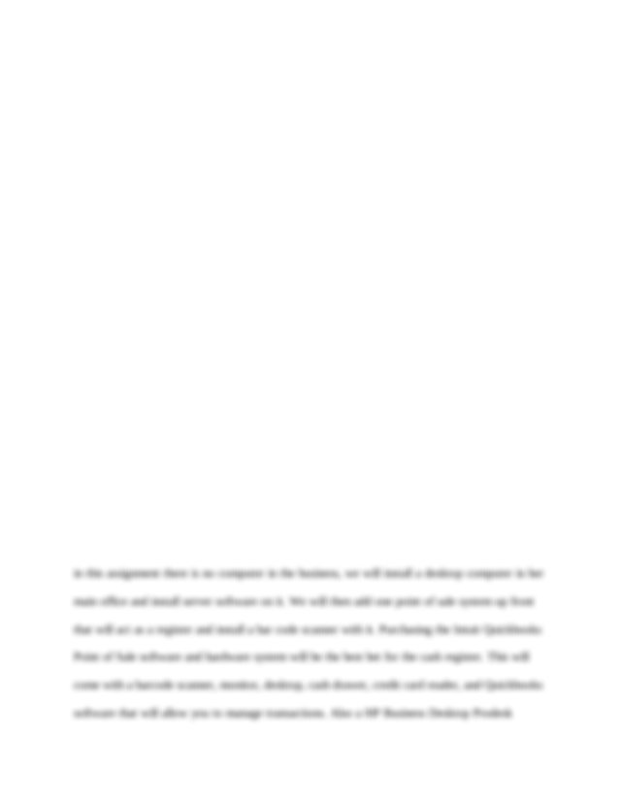

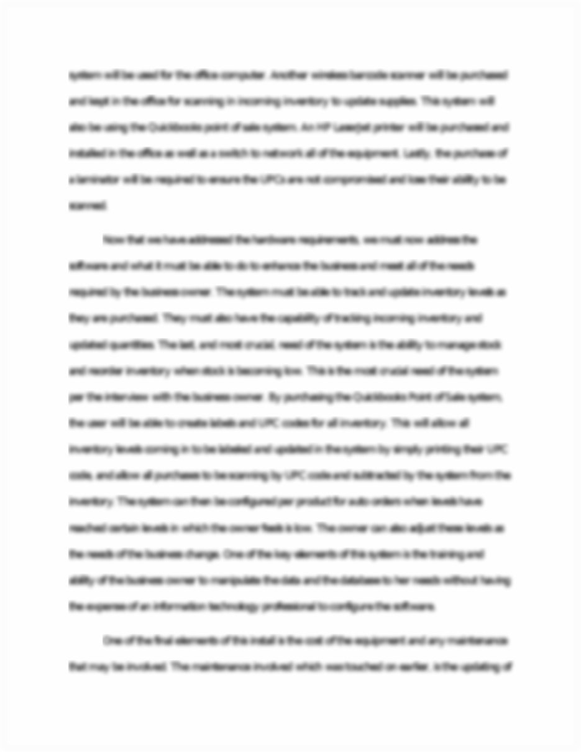

This is the end of the preview. [Sign up](https://www.coursehero.com/registerForm.php?reg_only=1&get_doc=11839859) to access the rest of the document.

This document was uploaded on 08/05/2015.

* **TERMSpring '15**
* **PROFESSOR**

[Report](https://www.coursehero.com/registerForm.php?login_user_type=document&user_action=flag&user_action_id=11839859)

[**View Full Document**](https://www.coursehero.com/registerForm.php?reg_only=1&get_doc=11839859)

**Most Popular Documents for CIS**

[8 pages[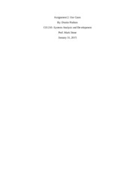](https://www.coursehero.com/file/11839860/Use-Cases/)](https://www.coursehero.com/file/11839860/Use-Cases/)

* + [Use Cases](https://www.coursehero.com/file/11839860/Use-Cases/)
  + [Strayer University Greenville campus](https://www.coursehero.com/file/11839860/Use-Cases/)
  + [CIS 210 - Spring 2015](https://www.coursehero.com/file/11839860/Use-Cases/)
  + [Assignment 2: Use Cases By: Dustin Hudson CIS 210- Systems Analysis and Development P](https://www.coursehero.com/file/11839860/Use-Cases/)

[Use Cases](https://www.coursehero.com/file/11839860/Use-Cases/)

[12 pages[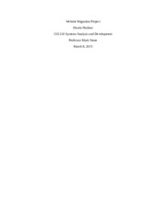](https://www.coursehero.com/file/11839861/Website-Migration-Project/)](https://www.coursehero.com/file/11839861/Website-Migration-Project/)

* + [Website Migration Project](https://www.coursehero.com/file/11839861/Website-Migration-Project/)
  + [Strayer University Greenville campus](https://www.coursehero.com/file/11839861/Website-Migration-Project/)
  + [CIS 210 - Spring 2015](https://www.coursehero.com/file/11839861/Website-Migration-Project/)
  + [Website Migration Project Dustin Hudson CIS 210 Systems Analysis and Development Prof](https://www.coursehero.com/file/11839861/Website-Migration-Project/)

[Website Migration Project](https://www.coursehero.com/file/11839861/Website-Migration-Project/)

[5 pages[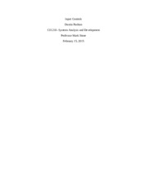](https://www.coursehero.com/file/11839856/Input-Controls/)](https://www.coursehero.com/file/11839856/Input-Controls/)

* + [Input Controls](https://www.coursehero.com/file/11839856/Input-Controls/)
  + [Strayer University Greenville campus](https://www.coursehero.com/file/11839856/Input-Controls/)
  + [CIS 210 - Spring 2015](https://www.coursehero.com/file/11839856/Input-Controls/)
  + [Input Controls Dustin Hudson CIS 210- Systems Analysis and Development Professor Mark](https://www.coursehero.com/file/11839856/Input-Controls/)

[Input Controls](https://www.coursehero.com/file/11839856/Input-Controls/)

[5 pages[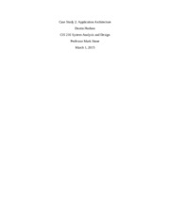](https://www.coursehero.com/file/11839857/Case-Study-2-Application-Architechture/)](https://www.coursehero.com/file/11839857/Case-Study-2-Application-Architechture/)

* + [Case Study 2 Application Architechture](https://www.coursehero.com/file/11839857/Case-Study-2-Application-Architechture/)
  + [Strayer University Greenville campus](https://www.coursehero.com/file/11839857/Case-Study-2-Application-Architechture/)
  + [CIS 210 - Spring 2015](https://www.coursehero.com/file/11839857/Case-Study-2-Application-Architechture/)
  + [Case Study 2: Application Architecture Dustin Hudson CIS 210 System Analysis and Desi](https://www.coursehero.com/file/11839857/Case-Study-2-Application-Architechture/)

[Case Study 2 Application Architechture](https://www.coursehero.com/file/11839857/Case-Study-2-Application-Architechture/)

[6 pages[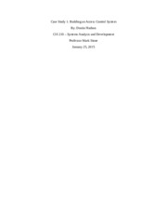](https://www.coursehero.com/file/11839858/Case-Study-1-building-an-access-control-system/)](https://www.coursehero.com/file/11839858/Case-Study-1-building-an-access-control-system/)

* + [Case Study 1 building an access control system](https://www.coursehero.com/file/11839858/Case-Study-1-building-an-access-control-system/)
  + [Strayer University Greenville campus](https://www.coursehero.com/file/11839858/Case-Study-1-building-an-access-control-system/)
  + [CIS 210 - Spring 2015](https://www.coursehero.com/file/11839858/Case-Study-1-building-an-access-control-system/)
  + [Case Study 1: Building an Access Control System By: Dustin Hudson CIS 210 Systems Ana](https://www.coursehero.com/file/11839858/Case-Study-1-building-an-access-control-system/)

[Case Study 1 building an access control system](https://www.coursehero.com/file/11839858/Case-Study-1-building-an-access-control-system/)

[8 pages[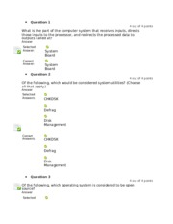](https://www.coursehero.com/file/12582780/CIS100-MIDTERMdocx/)](https://www.coursehero.com/file/12582780/CIS100-MIDTERMdocx/)

* + [CIS100 MIDTERM.docx](https://www.coursehero.com/file/12582780/CIS100-MIDTERMdocx/)
  + [Strayer University Greenville campus](https://www.coursehero.com/file/12582780/CIS100-MIDTERMdocx/)
  + [CIS 106 - Fall 2015](https://www.coursehero.com/file/12582780/CIS100-MIDTERMdocx/)
  + [Question 1 4 out of 4 points What is the part of the computer system that receives i](https://www.coursehero.com/file/12582780/CIS100-MIDTERMdocx/)

[CIS100 MIDTERM.docx](https://www.coursehero.com/file/12582780/CIS100-MIDTERMdocx/)

**Join our community of 10 million+ students and educators.**

Quick access to 10 million+ documents

Free plans that won't break your bank

24/7 homework help from tutors

**Our Better Grades Guarantee**[Terms](https://support.coursehero.com/hc/en-us/articles/218756988)

[**Sign Up Now**](https://www.coursehero.com/registerForm.php)

**Recently Viewed**

* 
  + **Website Migration Project**
  + Strayer University Greenville campus
  + CIS 210
* 
  + **Use Cases**
  + Strayer University Greenville campus
  + CIS 210
* 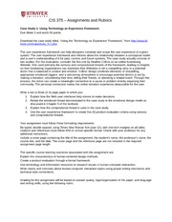
  + **LATE ASSIGNMENTS**
  + Strayer University Owings Mills campus
  + CIS 210
* 
  + **Case Study 1 building an access control system**
  + Strayer University Greenville campus
  + CIS 210
* 
  + **Case Study 2 Application Architechture**
  + Strayer University Greenville campus
  + CIS 210

**Study on the go**

* [Download the iOS app](https://itunes.apple.com/app/apple-store/id922208952?pt=108036802&ct=doc_landing&mt=8)
* [Download the Android app](https://play.google.com/store/apps/details?id=com.coursehero.coursehero&referrer=utm_source%3Dcoursehero%26utm_campaign%3Ddoc_landing)

